**Project Design Phase-II**

**Technology Stack (Architecture & Stack)**

|  |  |
| --- | --- |
| Date | 03 October 2022 |
| Team ID | PNT2022TMID20093 |
| Project Name | Project - IoT Based Smart Crop Protection System for Agriculture |
| Maximum Marks | 4 Marks |

**Technical Architecture:**

The Deliverable shall include the architectural diagram as below and the information as per the table1 & table 2

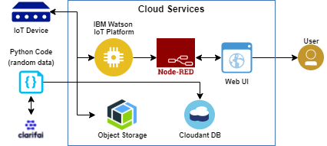

**Table-1: Components &Technologies**

|  |  |  |  |
| --- | --- | --- | --- |
| **S.No** | **Component** | **Description** | **Technology** |
| 1. | User interface | How user interacts with the web UI | HTML, CSS, JavaScript / Angular Js / React Js etc. |
| 2. | Application Logic-1 | Logic for a process in the application | Python |
| 3. | Application Logic-2 | Logic for a process in the application | IBM Watson/node red |
| 4. | Application Logic-3 | Logic for a process in the application | IBM Watson/node red |
| 5. | Database | Data Type, Configurations etc. | MySQL, NoSQL, etc. |
| 6. | Cloud Database | Database Service on cloud | IBM Cloudant |
| 7. | File Storage | File storage requirements | IBM Block Storage |
| 8. | Infrastructure(Server/cloud) | Application deployment on Local System/Cloud Local Server configuration:  Cloud sever configuration | Cloud Foundry |

**Table-2:Application Characteristics**

|  |  |  |  |
| --- | --- | --- | --- |
| **S.No** | **Characteristics** | **Description** | **Technology** |
| 1. | Open-Source frameworks | The open-source frameworks used | Software |
| 2. | Security implementations | List all the security/access controls implemented | Encryption process |
| 3. | Scalable architecture | Justify the scalability of architecture(3-tier, micro-services) | Software |
| 4. | Availability | Justify the availability of applications (eg. use of load balancers, distributed servers etc) | Software |
| 5. | Performance | Design consideration for the performance of the application | Software |